**[Image Noise Reduction Algorithms](http://electronicsbus.com/image-noise-reduction-algorithms-image-processing/" \o "Image Noise Reduction Algorithms)**

Noise reduction is the process of removing noise from a signal. Images taken with both digital cameras and conventional film cameras will pick up noise from a variety of sources. Image noise is the random variation of brightness or color information in images produced by the sensor and circuitry of a scanner or digital camera.

**Types of Noises in Image/Video Signals**

* **Salt and Pepper Noise**:- In salt and pepper noise (sparse light and dark disturbances), When viewed, the image contains dark and white dots, hence the term salt and pepper noise. Typical noise sources include flecks of dust inside the camera and overheated or faulty CCD elements. Fat-tail distributed or “impulsive” noise is sometimes called salt-and-pepper noise or spike noise.
* **Shot Noise**:- The dominant noise in the lighter parts of an image from an image sensor is typically that caused by statistical quantum fluctuations, that is, variation in the number of photons sensed at a given exposure level; this noise is known as photon shot noise.
* **Gaussian Noise**:- The grain of photographic film is a signal-dependent noise, related to shot noise. In Gaussian noise, each pixel in the image will be changed from its original value by a small amount. A histogram, a plot of the amount of distortion of a pixel value against the frequency with which it occurs, shows a normal distribution of noise. While other distributions are possible, the Gaussian (normal) distribution is usually a good model, due to the central limit theorem that says that the sum of different noises tends to approach a Gaussian distribution.
* **Quantization Noise (Uniform Noise)**:- The noise caused by quantizing the pixels of a sensed image to a number of discrete levels is known as quantization noise. It has an approximately uniform distribution, and can be signal dependent, though it will be signal independent if other noise sources are big enough to cause dithering, or if dithering is explicitly applied.
* **Non-Isotropic Noise**:- Some noise sources show up with a significant orientation in images. For example, image sensors are sometimes subject to row noise or column noise. In film, scratches are an example of non-isotropic noise.

**Noise Reduction Systems & Algorithms for Image/Video Noise**

* **Chroma and Luminance Noise Separation**:- In real-world photographs, the highest spatial-frequency detail consists mostly of variations in brightness (“luminance detail”) rather than variations in hue (“chroma detail”). Since any noise reduction algorithm should attempt to remove noise without sacrificing real detail from the scene photographed. In addition, most people find chroma noise in images more objectionable than luminance noise; the colored blobs are considered “digital-looking” and unnatural, compared to the grainy appearance of luminance noise that some compare to film grain. For these two reasons, most photographic noise reduction algorithms split the image detail into chroma and luminance components and apply more noise reduction to the former in-camera noise reduction algorithm.
* **Linear Image Smoothing Filters**:- One method to remove noise is by convolving the original image with a mask that represents a low-pass filter or smoothing operation. For example, the Gaussian mask comprises elements determined by a Gaussian function. This convolution brings the value of each pixel into closer harmony with the values of its neighbors. In general, a smoothing filter sets each pixel to the average value, or a weighted average, of itself and its nearby neighbors; the Gaussian filter is just one possible set of weights.
* **Anisotropic Diffusion**:- Another method for removing noise is to evolve the image under a smoothing partial differential equation similar to the heat equation which is called anisotropic diffusion. With a spatially constant diffusion coefficient, this is equivalent to the heat equation or linear Gaussian filtering, but with a diffusion coefficient designed to detect edges, the noise can be removed without blurring the edges of the image.
* **Nonlinear Image Filters**:- A median filter is an example of a non-linear filter and, if properly designed, is very good at preserving image detail. To run a median filter: 1. consider each pixel in the image, 2. sort the neighbouring pixels into order based upon their intensities, 3. replace the original value of the pixel with the median value from the list.

## A two-sided but extremely biased comparison of noise reduction software

*by Glenn Chan*

The purpose of this article is to compare the pros and cons of Boundary Noise Reduction (BNR) compared to what I consider the leading competing products:

* [Denoise](http://www.topazlabs.com/denoise/) by Topaz Labs
* [Noiseware](http://www.imagenomic.com/nwpg.aspx) by Imagenomic
* [Noise Ninja](http://www.picturecode.com/) by PictureCode

***Please note that I may be extremely biased as my software competes against these other excellent noise removal tools!!!***

With that being said, I will try to give a fair two-sided view on the noise reduction products on the market. Of course, you should try all the demos for the products yourself and make up your own mind!

### A little secret: automatic profiling does not always work!

For automatic profiling to work, the source image must have an area where there is no detail (i.e. the area is completely smooth) and only noise. This is not the case if there are no smooth areas in the picture to begin with. Automatic profiling can miss in such a situation, and you should manually tweak the noise reduction settings instead.

Another instance where automatic profiling tends to work poorly is if the camera applies its own noise reduction when recording to JPEG file formats. This can cause the profiling algorithm to get the characteristics of the remaining noise wrong.

For this and various other reasons, automatic profiling does not always work. There are some cases where the profiling is way off and manual intervention is needed to bring out the best results. Please keep that in mind since all the examples in this article are based on automatic settings.

### Test Image #1

All images are zoomed in 200%, nearest neighbour resizing. There is extreme noise in this random image of a newspaper sitting on a mall bench.

For Denoise, the best-looking preset was chosen. For all the others, automatic profiling was used. There was no manual tweaking of noise reduction parameters/settings.

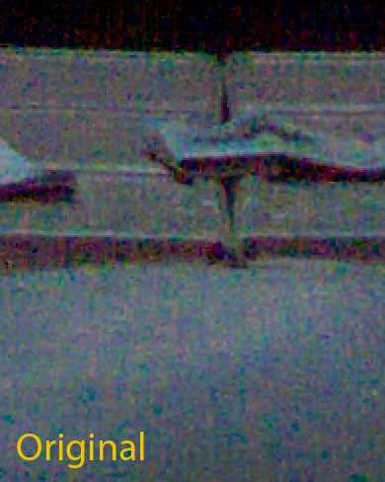  
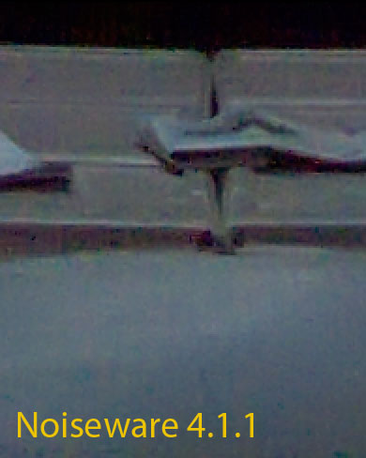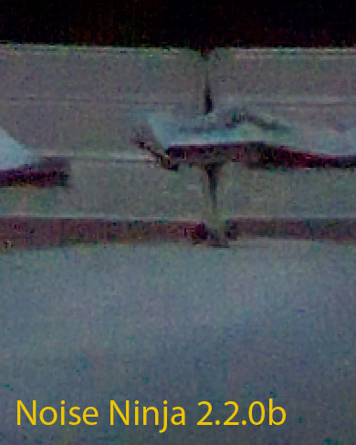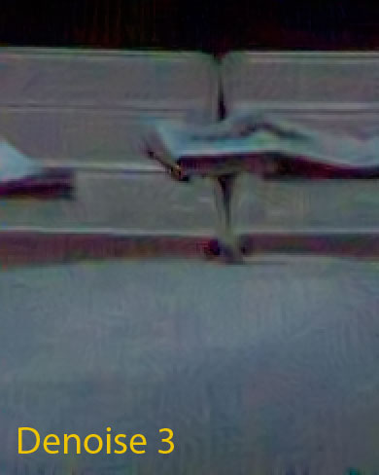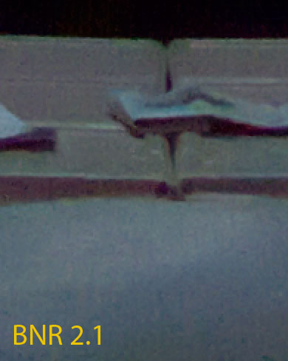

## Commentary

|  |  |
| --- | --- |
| Noiseware | Noiseware Noiseware does a good job of removing noise. However, the red arrows point out erroneous artifacts left behind by the algorithm.  Setting the noise level higher in Noiseware would remove these artifacts (at the expense of image detail).  **Note**: Adobe Camera RAW was used to process the image. ACR tends to be aggressive about recovering detail and may leave behind debayering/demoasicing artifacts which noise reduction software can exaggerate. The choice of RAW processing will affect noise reduction results. |
| noise ninja | Noise Ninja Like Noiseware, Noise Ninja also has problems with the same artifacts.  Unlike Noiseware, Noise Ninja is retaining more of the original image's luma information. It is also applying more aggressive sharpening. In many situations, this can be appropriate since many objects do not look right if they lack enough texture. The aggressive sharpening also counteracts the blurriness that can occur when noise in removed. Unfortunately in this situation, these aggressive defaults are inappropriate. |
| denoise | Denoise Denoise tends to give very different results. It does an excellent job at recovering image detail (in my opinion, it is the best at it). Unfortunately, it will also recover image details that do not really exist.  One problem with noise reduction is that the algorithm cannot always figure out what is detail and what is noise. When noise is confused with detail, artifacts usually result. In situations such as this, Denoise can create spurious "worm-like" patterns. |
| BNR 2 | Boundary Noise Reduction Here, BNR is conservative in its noise reduction and perhaps overly so. It does not exhibit the artifacts that Noise Ninja and Noiseware does. At the same time, it does not have as much contrast as Noiseware does; the Noiseware results appear sharper.  The conservatism is due to 2 things:   1. The profiling in BNR errs on the safe side, and therefore the **noise level** setting in BNR is usually set too high. 2. BNR defaults to significantly less sharpening than the other plug-ins presented here.   So there are not a lot of artifacts and not as much sharpness or detail either. |

### Test image #2

This image of string contains a lot of fine detail and is a good demonstration of the ability to remove noise while removing as little detail as possible.

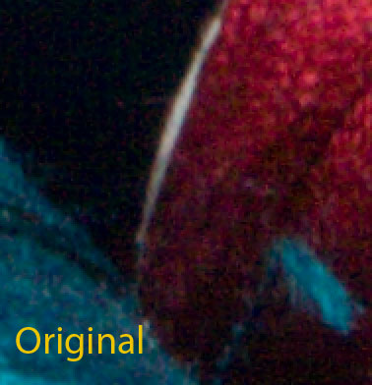  
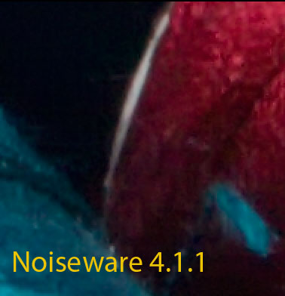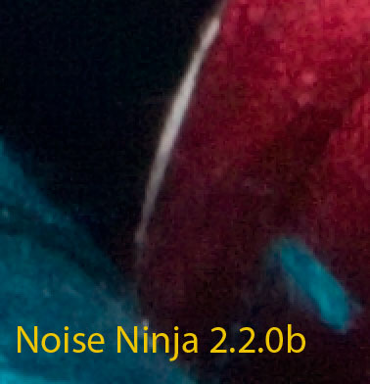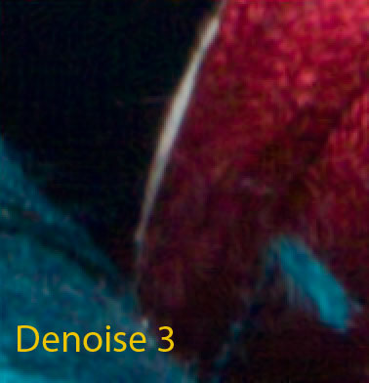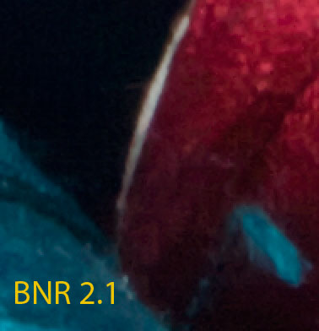

## Commentary

In the images above, it may be difficult to see the differences. You can download the images as a layered PSD file for better comparisons: [String example [973kB]](http://www.colormancer.com/whitepapers/noise-reduction-comparison/nr-comparison-article-images/strings-crop-02.psd) * [Bench example [1253kB]](http://www.colormancer.com/whitepapers/noise-reduction-comparison/nr-comparison-article-images/bench-crops-02.psd)

This situation is particularly favorable for Denoise as it can really extract a lot of detail while also getting rid of noise. Unfortunately, it also suffers from the worm-like artifacts as in the bench example (especially in the shadow areas). Manual intervention would be needed to remove these artifacts either by tweaking the filter settings or by using layer masks to remove them.

Noiseware does a good job but has problems dealing with noise outliers in the image.

Between Noise Ninja and Boundary Noise Reduction, the differences are mainly due to Noise Ninja using more aggressive profiling and sharpening.

## Speed

Render times for a 10 megapixel image:

|  |  |
| --- | --- |
| Noiseware | 5.95s |
| Noise Ninja (Turbo mode) | 6.37s |
| Boundary Noise Reduction | 7.44s |
| Denoise | 62.45s |

Noiseware and Noise Ninja are the fastest of the bunch, while Denoise is a magnitude slower than the rest.

*\*Please note that all times are approximate and vary depending on your system hardware, OS, other processes running, etc. etc. You should download the demos for each software and test for yourself.*

## Advantages of each product

If you have an image with extreme noise and need to "polish a turd" so to speak, **Topaz Labs' Denoise** is likely your best bet. It can recover detail that the other products cannot. For even better results, you can combine it with Boundary Noise Reduction as BNR tends to do a better job with chroma noise reduction. Duplicate the noisy image onto its own layer, apply BNR, and set the blending mode on the layer to "Color". This is the simplest method. You can also achieve similar results by setting "mix in original B&W detail" to 1 in BNR and apply BNR before Denoise.

For fastest processing times, consider **Noiseware** and **Noise Ninja**.

If you want conservative noise reduction with few artifacts, consider **Boundary Noise Reduction**.

But don't take my word for it! Please try the demos for each product yourself and come to your own conclusions. Each product tends to have its fans and all of them will do a good job at removing noise.

### Other noise reduction products

This article does not cover other noise reduction software such as:

* [Neat Image](http://www.neatimage.com/) by ABSoft
* [Dfine](http://www.niksoftware.com/dfine/usa/entry.php) by Nik Software
* [Picture Cooler](http://denoiser.shorturl.com/)
* and many others... (too numerous to mention)